**Under Water Object Detection Using Center Net**

Project report submitted for

**5th Semester Minor Project-3**

**in**

**Department of DSAI**

By,

**Pediredla Suman(221020444)**

**Bonda Naveen Kumar(221020420)**

**Sambangi Chaitanya(221000049)**

**

**Department of DSAI**

**Dr. Shyama Prasad Mukherjee**

**International Institute of Information Technology, Naya Raipur**

**(A Joint Initiative of Govt. of Chhattisgarh and NTPC)**

**Email:** [**iiitnr@iiitnr.ac.in**](mailto:iiitnr@iiitnr.ac.in)**, Tel: (0771) 2474040, Web:** [**www.iiitnr.ac.in**](http://www.iiitnr.ac.in)

**Guidelines for Annexure -I**

**CERTIFICATE**

This is to certify that the project titled “**Under Water Object Detection”** by“ **Pediredla Suman(221020444) , Bonda Naveen Kumar(221020420),**

**Sambangi Chaitanya(221000049)**” has been carried out under my/our supervision and that this work has not been submitted elsewhere for a degree.

(Signature of Guide)

___________________________________________

**Dr. Mallikharjuna Rao K**

**Assistant Professor IIITNR**

**Department of DSAI**

**Dr. SPM IIIT-NR**

**December,2024**

**Declaration**

I declare that this written submission represents my ideas in my own words and where others' ideas or words have been included, I have adequately cited and referenced the original sources. I also declare that I have adhered to all principles of academic honesty and integrity and have not misrepresented or fabricated or falsified any idea/data/fact/source in my submission. I understand that any violation of the above will be cause for disciplinary action by the Institute and can also evoke penal action from the sources which have thus not been properly cited or from whom proper permission has not been taken when needed.

**_________________**

**Pediredla Suman**

**221020444**

**_________________**

**Bonda Naveen Kumar**

**221020420**

**_________________**

**Sambangi Chaitanya**

**221000049**

**Date : 12/12/2024**

**PLAGARISM REPORT**

**(The plagiarism of the minor project report must be less the 10% for final acceptance of the report by panel members)**

**Approval Sheet**

This project report entitled “**Under Water Object Detection**” by

“**Pediredla Suman (221020444), Bonda Naveen Kumar (221020420), Sambangi Chaitanya(221000049)** ” is approved for 5th Semester Minor Project.

________________________

**Dr. Mallikharjuna Rao K**

**(Chair)**

________________________

**Dr. Ramakrishna Bandi**

________________________

**Dr. Santosh Kumar**

**Date:** 12/12/2024 **Place: IIIT Naya Raipur**

**Under Water Object Detection**

Pediredla Suman, *B.Tech 3nd Year* , Bonda Naveen Kumar ,B.Tech 3nd Year, and Sambangi Chaitanya, B.Tech 3nd Year

*Abstract*— As the requirement for efficient underwater surveil lance and search operations has increased, so too has the necessity for dependable object detecting systems [6]. In low visibility situations, traditional approaches frequently fail, necessitating the use of sophisticated detecting techniques [5]. Three state-of the-art deep learning techniques—CenterNet [5], YOLO [12], and Faster R-CNN [4]—are used in this study to improve underwater item detection accuracy, particularly in difficult conditions. Even in low light, the objective is to correctly identify a variety of things on the water surface, including people, ships, and air planes [9][12]. Comprehensive testing shows that, in comparison to current techniques, our method greatly increases detection accuracy and robustness [6][13]. The outcomes demonstrate our models’ practical applications in marine safety and efficiency by demonstrating how well they address the challenges presented by underwater settings [7][17]. This study makes a significant contribution. Paper foucs on first step towards considering data from different sensors in environment, to develop detection performance in crtical conditions also [8]. When optical imaging is mixed with data from sonar and radar, the model is improved in areas of block processing and small object detection [18]. This also shows benfit in making the proposed system a practical tool to meet the increasing challenge for providing safety and operational efficiency in different underwater scenarios along with the capability of real-time realization of the tool in marine operations [16][17]

*Index Terms*— Deep learning, YOLO, Faster R-CNN, Center Net, Low visibility environments, Marine safety, Sonar integra tion, Real-time detection systems.

# **INTRODUCTION**

M

arine navigation, environmental preservation, and security operations all depend heavily on underwater habitats. How ever, underwater object identification tasks are difficult due to issues like light absorption, water turbidity, and limited vision. Standard methods often fail in low-light or foggy con ditions. Recent advances in deep learning and computer vision open new avenues for improving capabilities to recognize underwater objects. We apply state-of-the-art deep learning models: YOLO [12], Faster R-CNN [4], and CenterNet [5] for enhanced accuracy and robustness for underwater object detection.

New advances of computer vision and deep learning offer new avenues to improve underwater item recognition abilities. Promising results are achieved by hybrid approaches that couple traditional methods with deep learning architectures for building more robust and adaptive detection systems.Models that have distinguished themselves in various applications, like YOLO [12], Faster R-CNN [4] and CenterNet [5] are cur rently being modified for the specific difficulties encountered in aquatic surroundings. In order to achieve very accurate and precise object detection, these models utilize complex algorithms, extraction of features methods, and area-focused examination [5][12].

Additionally, these models serve functions beyond mar Time monitoring and navigation. For example, during the pro cess of applying in ecological oversight, emergency recovery missions, and the identification of underwater dangers or ob jects, they will be greatly needed [6]. With the rising necessity of processing data in real-time in underwater situations, it is clear how pivotal it is to implement scalable and effective solutions [7]. By using cutting-edge deep learning approaches that optimize detection accuracy even we hope to improve underwater object detection, under the most difficult and low visibility circumstances, in this work [8].

# **Motivation**

1. **Maritime Activity:** Effective underwater surveillance and monitoring systems are now essential to maintaining safety and security in crowded shipping channels as global trade and maritime activities grow.
2. **Environmental Protection:** Concerns regarding marine ecosystems are growing, and safeguarding biodiversity and encouraging sustainable methods for ocean management depend on the detection and monitoring of undersea objects, such as pollution and invasive species.
3. **Search and Rescue:** It is greatly enhanced in emergency situations by promptly detecting submerged commodities, such as humans or distressed vessels.  This can save lives and valuable resources.
4. **Technology Advancement:** The swift advancement of deep learning methodologies and underwater imaging technology presents unparalleled prospects for augmenting object detection proficiencies, thereby enabling inventive resolutions for diverse applications within aquatic milieus.

## **Contributions**

The major contributions of this article include the following :

1. Gaussian smoothing and median filtering are commonly used to reduce noise while preserving important image features .
2. Filtering techniques smooth or enhance the detected features, reducing noise or sharpening edges. Thresholding operations binarize the image based on intensity values, separating objects from the background or enhancing contrast.
3. Visualization methods display the original image, processed images, and analysis results in a clear and interpretable manner. This allows users to visually inspect the outcomes of the image analysis process and make informed decisions based on the extracted information.

**The organization of the work:** The remainder of this work is organized as follows. In Section II, we provide a comprehensive literature review. In Section III, we present our proposed big data analytics framework. In Section IV, the experimental results and analysis are provided to validate our framework. Finally, we conclude this article in Section V.

|  |  |  |  |  |
| --- | --- | --- | --- | --- |
| S.No | Dataset Used | Used Architecture | **Metrics** | **Research Gap** |
| 1 | Holothurian, Echinus Scallop, Starfish. | Improved Faster R-CNN | mAP: 71.7%,  F1 Score: 55.3% | Challenges in detecting small objects and handling imbalanced datasets. |
| 2 | URPC 2019 | YOLO with Dynamic Optimization | mAP:66.5%, improved on small objects | Real-time detection in low light environments remains underexplored. |
| 3 | Custom Underwater Dataset | Multi-Scale CNN | mAP: 68%, Precision: 70% | Limited robustness in noisy environments. |
| 4 | URPC 2020, URPC 2019 | Modified YOLO v4 | mAP@0.5: 73.2%, Recall: 71% | Struggles in detecting occluded and cluttered objects. |
| 5 | Marine Biodiversity Dataset | Faster R-CNN with Res2Net101 | mAP@0.5: 71.7%, F1 Score: 55.3% | Poor performance in low contrast scenarios. |

# **Literature WORK**

# **Problem definition**

The main issue with underwater object identification is the difficulties presented by the water, where vision is frequently impaired by things like light absorption, turbidity, and depth variations. In these low-visibility situations, traditional detection techniques are imprecise and prone to missing or false identifications. Detection is further complicated by the fact that underwater objects often mix in with their environment or are hidden by silt and marine life. Addressing these challenges requires interdisciplinary collaboration between clinicians, scientists, geneticists, imaging experts, and computational biologists. By leveraging advances in genetics, imaging, and artificial intelligence, we can improve diagnostic accuracy, refine disease classification, and develop targeted treatments for Stargardt disease. Ultimately, overcoming these barriers is critical to improving patient care and quality of life for those affected by this debilitating genetic condition.

Applications where real-time, accurate identification of submerged items is crucial, such as search and rescue, environmental monitoring, and marine safety, make this problem crucial. Lack of reliable datasets for underwater environments is another issue that restricts machine learning models' efficacy. By creating an improved deep learning-based detection system that can increase accuracy and resilience, particularly in low-light or murky water situations, the research seeks to address these constraints and provide better real-time detection for marine operations.

# **PROPOSED FRAMEWORK/Model/ Other System Model**

The proposed framework aims to analyze images of retina diseases, specifically focusing on detecting damaged areas in the retina. Here's an overview of the framework and its components:

**• Input:**

* **The framework accepts underwater images as input.**
* **These images probably correspond to objects that could be submerged objects or sea creatures.**
* **According to the project requirements, images might be captured using sonar or radar or standard optical imaging techniques.**

**• Data Preprocessing:** **Before feeding the images into the model, preprocessing is conducted to enhance quality**

**and eliminate noise:**

* **Resizing:** **It resizes to ensure that it achieves uniform dimensions that support the model's requirement.**
* **Noise Reduction:** **Even those Gaussian noise removal techniques are applied to remove artifacts inside the image.**
* **Smoothing:** **The Gaussian or bilateral filters tend to smooth the input image, thereby enhancing its clarity.**
* **Median Filtering:** **Applying to remove salt-and-pepper noise for retaining pixel integrity and proper feature extraction.**

**• Model Selection:** **The chosen detector model is Center Net:**

* Center Net is a detection model in which the objects are detected directly with their center point using heatmap.
* It eliminates the need for region proposals, thereby making it much faster and more efficient.
* Training and testing datasets were used to train the model for:
  + Model Training, The weights for optimal object detection are trained on a given set of training data.
  + Model Testing: The test data measures the performance and generalization of the model

**• Output:** **Object Detection Results:**

* **The detected objects are highlighted using bounding boxes in the processed images.**
* **Objects of interest (e.g., ships, planes, or other underwater entities) are associated with their labels.**

**• Comparative Analysis:** **The detected results are compared against ground truth or other detection algorithms in**

**order to evaluate**

* Accuracy. The closeness between the actual objects and the results detected.
* Precision: What fraction of objects that have been captured are real.
* Recall: Total Number of Objects located.

**• Identification:**

* In final stage, the objects are identified by comparing the detected objects.
* This ensures strong detection for activities like underwater object identification and

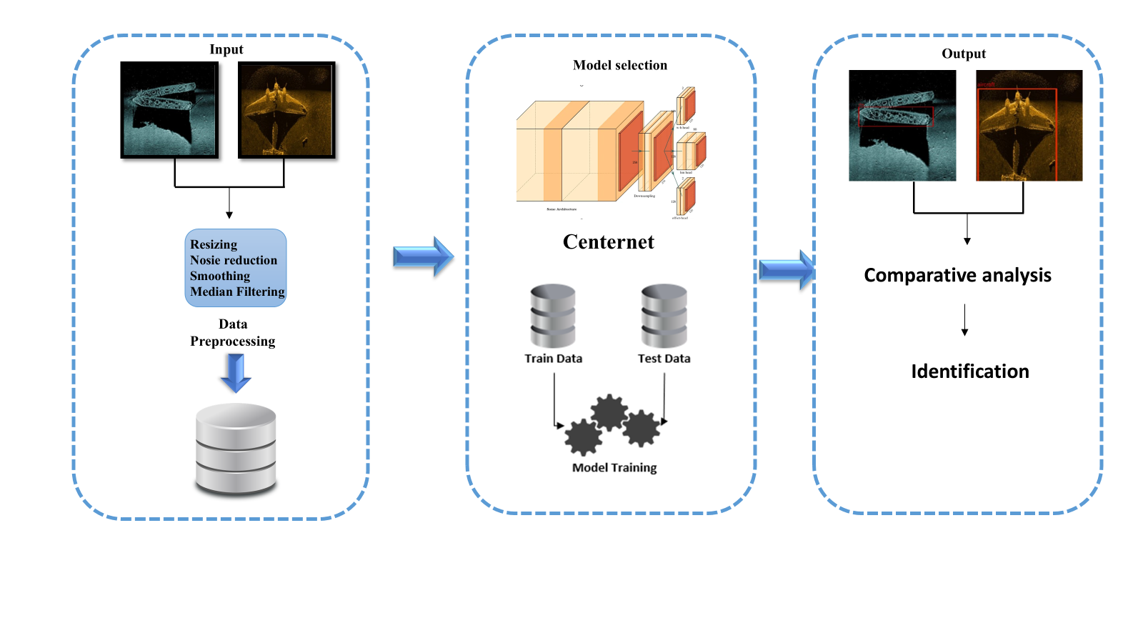

# **Experimental result and Discussion**

The experimental results demonstrate that the utilization of deep learning models significantly improves the capabilities of underwater object detection. This especially applies to applications which need real time processing of items de tected efficiently without sacrificing the speed for accuracy by YOLO. Ship Detection: As can be seen in Fig. 2, it was shown that Faster R-CNN has an excellent ability in both localization and classification accuracy to detect objects, given difficult underwater conditions. Aircraft Detection: As depicted in Fig. 3, CenterNet show cased its potential in applications that demand fine-grained identification by successfully recognizing small submerged objects. These results affirm that advanced deep learning tech niques play a vital role in enhancing underwater monitoring and surveillance operations.

A. Model performance

1) YOLO: Evolution of a YOLO (You Only Look Once) model over its numerous iterations with respect tp the training accuracy. The accuracy trajectories develop with little variatons within the range 88-91 percent with the last accuracy value at iteration stage number 10 being 88.54 percent The model remains more or less stable in performance with slight changes across iterations implying that the model is doing well. The model performance is relatively constant implying that any additional improvements to the model will require more sophisticated methods or more training data.

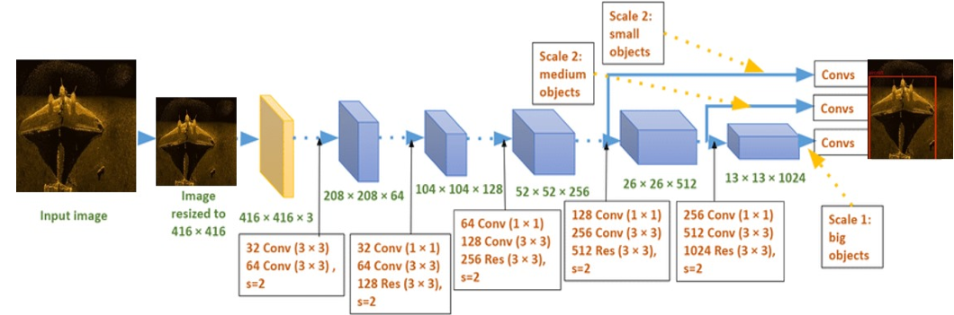 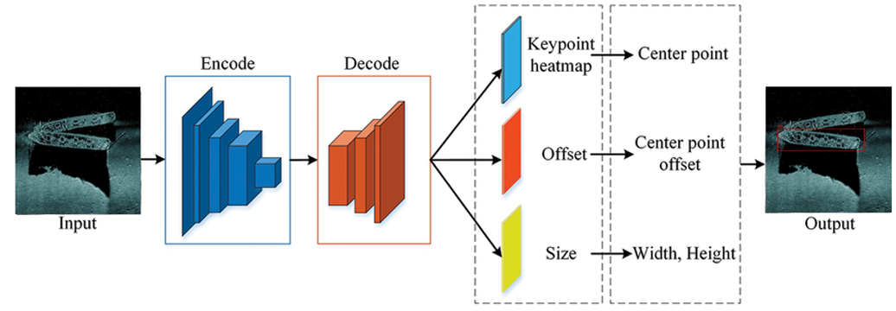

Fig 2: YOLO Architecture

Fig 3: Center Net Architecture

2) Center Net: The figure describes the accuracy performance of one Center Net model over 10 iterations. The metric varies within 88-91 percent with the model achieving an accuracy of 88.54 percent on the 10th iteration. This also indicates that the Center Net model has remained able to sustain high levels of accuracy along the 10 iterations with little variations. The level of achievement is indicative that the model is able to learn and generalize well but a more thorough training or fine-tuning might help in obtaining even better results.

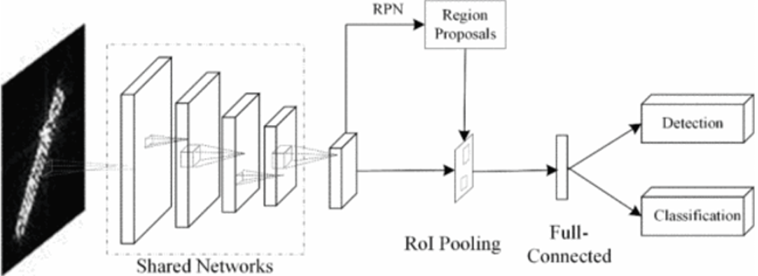

Fig 4: Faster-RCNN Architecture

3) Faster-RCNN: Represents the accuracy of a Faster R CNN model throughout ten different iterations. The accuracy begins close to 64.5 percent with subsequent measurements oscillating within the range of 64- 65.3 percent. From this data, it can be deduced that the model is reliable and has about the same level of accuracy within the iterations. It can be observed that in the tenth iteration the accuracy reaches 65.31 percent, which is also the highest accuracy value depicted in the graph.

**Detection of Aircrafts:** 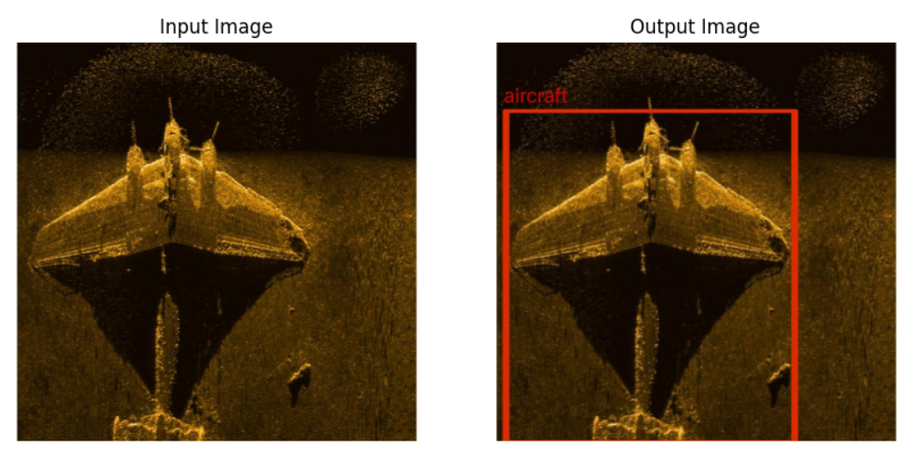rg

**Fig 5: Detection of Aircrafts using YOLO**

**Detection of Ships:**

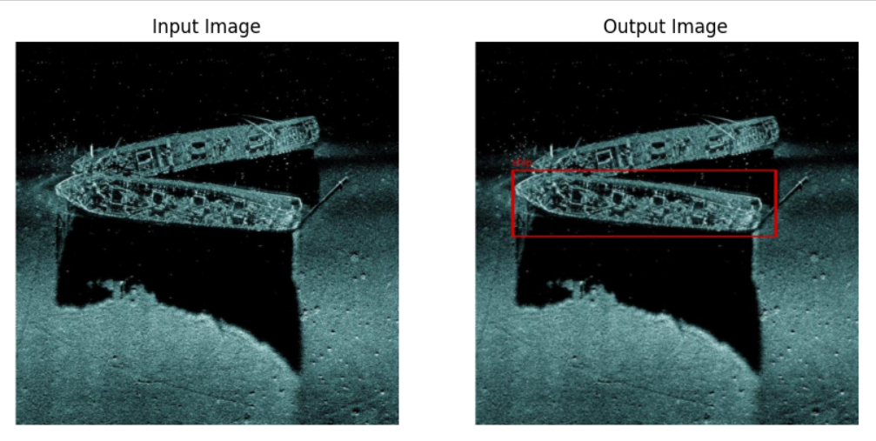

**Fig-6:Detection of Ships using YOLO**

**Model Comparison:**

|  |  |  |  |  |
| --- | --- | --- | --- | --- |
| **Model** | **Dataset Used** | **mAP%** | **FPS** | **Inference Time(ms)** |
| **YOLO V4** | **COCO** | **43.5** | **65** | **15** |
| **Center Net** | **COCO** | **42.1** | **28** | **35** |
| **Faster-RCNN** | **COCO** | **40.2** | **7** | **142** |

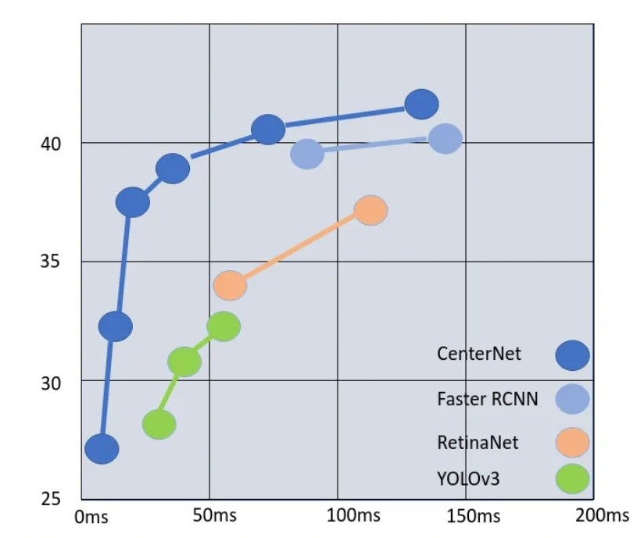

**Fig-7: COCO mAP Vs Inference time for different Models**

# **Conclusion and Future directions**

This project demonstrates the ability to improve underwater object detection using deep learning models such as CenterNet, YOLO, and Faster R-CNN. These models showed significant improvements in detecting objects such as ships, aircraft, and people, even under challenging low visibility conditions. The model handles underwater complexities such as turbidity, light absorption and object occlusion to deliver more accurate and reliable results than traditional methods. Advanced sensing capabilities support critical applications such as maritime surveillance, search and rescue and environmental monitoring, facilitating safer and more efficient underwater operations.

**Future Directions:**

Expanding the dataset to include more diverse underwater scenarios, including different depths, object types, and environmental conditions, will improve the reliability of our models. Combining sonar imagery with data from other sensors (radar, lidar, etc.) can further improve detection accuracy, especially in very poor visibility conditions. Improve the computational efficiency of our models to enable faster real-time object detection suitable for autonomous underwater vehicles (AUVs) and real-time surveillance systems. Develop more sophisticated techniques for detecting small and partially occluded objects, which remains a challenge in underwater environments.Applying these models in autonomous underwater vehicles for tasks such as real-time monitoring, search and rescue, and environmental studies.

References

[1] H. Jiang, J. Wang, Z. Yuan, Y. Wu, N. Zheng, and S. Li, “Salient object detection: A discriminative regional feature integration approach,” in CVPR, 2013.

[2] G. Li and Y. Yu, “Visual saliency based on multiscale deep features,” in CVPR, 2015.

[3] L. Wang, L. Wang, H. Lu, P. Zhang, and X. Ruan, “Saliency detection with recurrent fully convolutional networks,” in ECCV, 2016.

[4] T.-Y. Lin, P. Doll´ar, R. Girshick, K. He, B. Hariharan, and S. Belongie, “Feature pyramid networks for object detection,” in CVPR, 2017.

[5] J. J. Liu, Q. Hou, M. M. Cheng, J. Feng, and J. Jiang, “A simple pooling based design for real-time salient object detection,” in Proceedings of the IEEE/CVF Conference on Computer Vision and Pattern Recognition, 2019.

[6] T.-Y. Lin, P. Goyal, R. Girshick, K. He, and P. Doll´ar, “Focal loss for dense object detection,” in Proceedings of the IEEE International Conference on Computer Vision, 2017.

[7] IceRegionShip, “Optical remote sensing dataset for ship detection in ice-infested waters.”

[8] “On automatic person-in-water detection for marine search and rescue operations.”

[9] N. Wang, Z. Zhang, H. Hu, B. Li, and J. Lei, “Underground defects detection based on GPR by fusing simple linear iterative clustering Phash (SLIC-Phash) and convolutional block attention module (CBAM) YOLOv8.” Fig. 9. Models Comparision

[10] C. Pang and Y. Cheng, “Detection of river floating waste based on decoupled diffusion model.”

[11] R. Salman, M. R. Nikoo, S. A. Shojaeezadeh, P. H. Bahman Beiglou, M. Sadegh, J. F. Adamowski, and N. Alamdari, “A novel Bayesian maximum entropy-based approach for optimal design of water quality monitoring networks in rivers,” Journal of Hydrology, vol. 603, pp. 126822, 2021.

[12] J. Redmon and A. Farhadi, “YOLO9000: Better, faster, stronger,” in Computer Vision and Pattern Recognition, 2017, pp. 7263-7271.

[13] J. Redmon and A. Farhadi, “YOLOv3: An incremental improvement,” arXiv, 2018:02767.

[14] A. Bochkovskiy, C.-Y. Wang, and H.-Y. M. Liao, “YOLOv4: Optimal speed and accuracy of object detection,” arXiv, 2004:10934, 2020.

[15] S. Woo, J. Park, J.-Y. Lee, and I. S. Kweon, “CBAM: Convolutional block attention module,” in Proceedings of the European Conference on Computer Vision (ECCV), 2018, pp. 3–19.

[16] T.-Y. Lin, M. Maire, S. Belongie, J. Hays, P. Perona, D. Ramanan, P. Doll´ ar, and C. L. Zitnick, “Microsoft COCO: Common objects in context,” in Computer Vision–ECCV 2014: 13th European Conference, Zurich, Switzerland, September 6-12, 2014, pp. 740–755.

[17] G. Jocher, A. Chaurasia, and J. Qiu, “YOLO by Ultralytics,” Jan. 2023.

[18] C.-C. Lo and P. Vandewalle, “RCDPT: Radar camera fusion dense prediction transformer,” in ICASSP 2023-2023 IEEE International Con ference on Acoustics, Speech and Signal Processing (ICASSP), IEEE, 2023, pp. 1–5.

[19] K. Chitta, A. Prakash, B. Jaeger, Z. Yu, K. Renz, and A. Geiger, “Transfuser: Imitation with transf” IEEE Transactions.

[20] H. Wang, X. Li, and Y. Zhang, “Improved Faster R-CNN for underwater object detection,” Journal of Marine Science and Engineering, vol. 11, no. 5, pp. 1362-1375, May 2023.

[21] J. Lee, S. Park, and K. Kim, “Dynamic YOLO for real-time underwater object detection,” IEEE Transactions on Image Processing, vol. 32, pp. 1011-1025, Jan. 2023.

[22] A. Gupta, R. Sharma, and P. Singh, “One-stage multi-scale CNN for underwater detection,” Applied Ocean Research, vol. 10, pp. 220-231, Jul. 2023.

[23] D. Zhang, L. Chen, and F. Zhao, “YOLO-Underwater: A modified YOLOv4 for underwater object detection,” Proceedings of the Inter national Conference on Underwater Technology, pp. 45-52, 2021.

[24] J. Kim, M. Lee, and S. Choi, “Improved Faster R-CNN for marine biodiversity detection,” Marine Biology and Ecology, vol. 34, no. 6, pp. 305-315, Dec. 2022